OSINT Tool Guide & Demonstration: MASTO



**🐘 About Masto -**

**Masto provides information/intelligence on**[**Mastodon.social**](https://mastodon.social/)**users and fediverse instances (servers).**  
Masto OSINT Tool has been added as a Python package on PyPI --> <https://pypi.org/project/masto/>

* Latest version --> <https://pypi.org/project/masto/2.0.5/>

**🚀 Masto capabilities -**

**Masto OSINT Tool** helps to:

* Find user ID
* Find exact username match across instances (the tool currently pulls many accounts with the username **OSINT**, whereas the mastodon.social (browser search bar) returns one result, as well as returning unreliable results, such as accounts that only start with osint
* Find all accounts belonging to a user without logging in to Mastodon (**Mastodon requires users to log in and after 5 results you get**: 401 Search queries pagination is not supported without authentication
* Find username correlation (can't be found by browser)
* Check if the user is a bot
* Check if the account is a group
* Check if the account is locked
* Check if the user opted to be listed on the profile directory
* Get avatar link with an **additional choice** of opening the avatar within your browser
* Get profile creation date
* Get number of followers & following
* Get number of posts
* Get user last status date
* Get user's bio

**Additional instance (server) feature -**

**This is a nice feature**, if you type social.network.europa.eu on [Mastodon.social](https://mastodon.social/search) , you won't get a result as the instance is set to not discoverable.

**This function helps to**:

* Get information on an instance
* Get instance Admin ID
* Get instance email
* Get a short description
* Get server thumbnail link
* Get instance creation date
* Get instance language used
* Get instance admin count of followers and following
* Get instance admin last status date
* Get header image link and avatar link
* Get instance display name
* Get admin url
* Get admin avatar
* Check if instance admin account is locked
* Check if registration is required and if the admin needs to approve the request
* Check if the admin is a bot

**Masto WorkFlow -**

[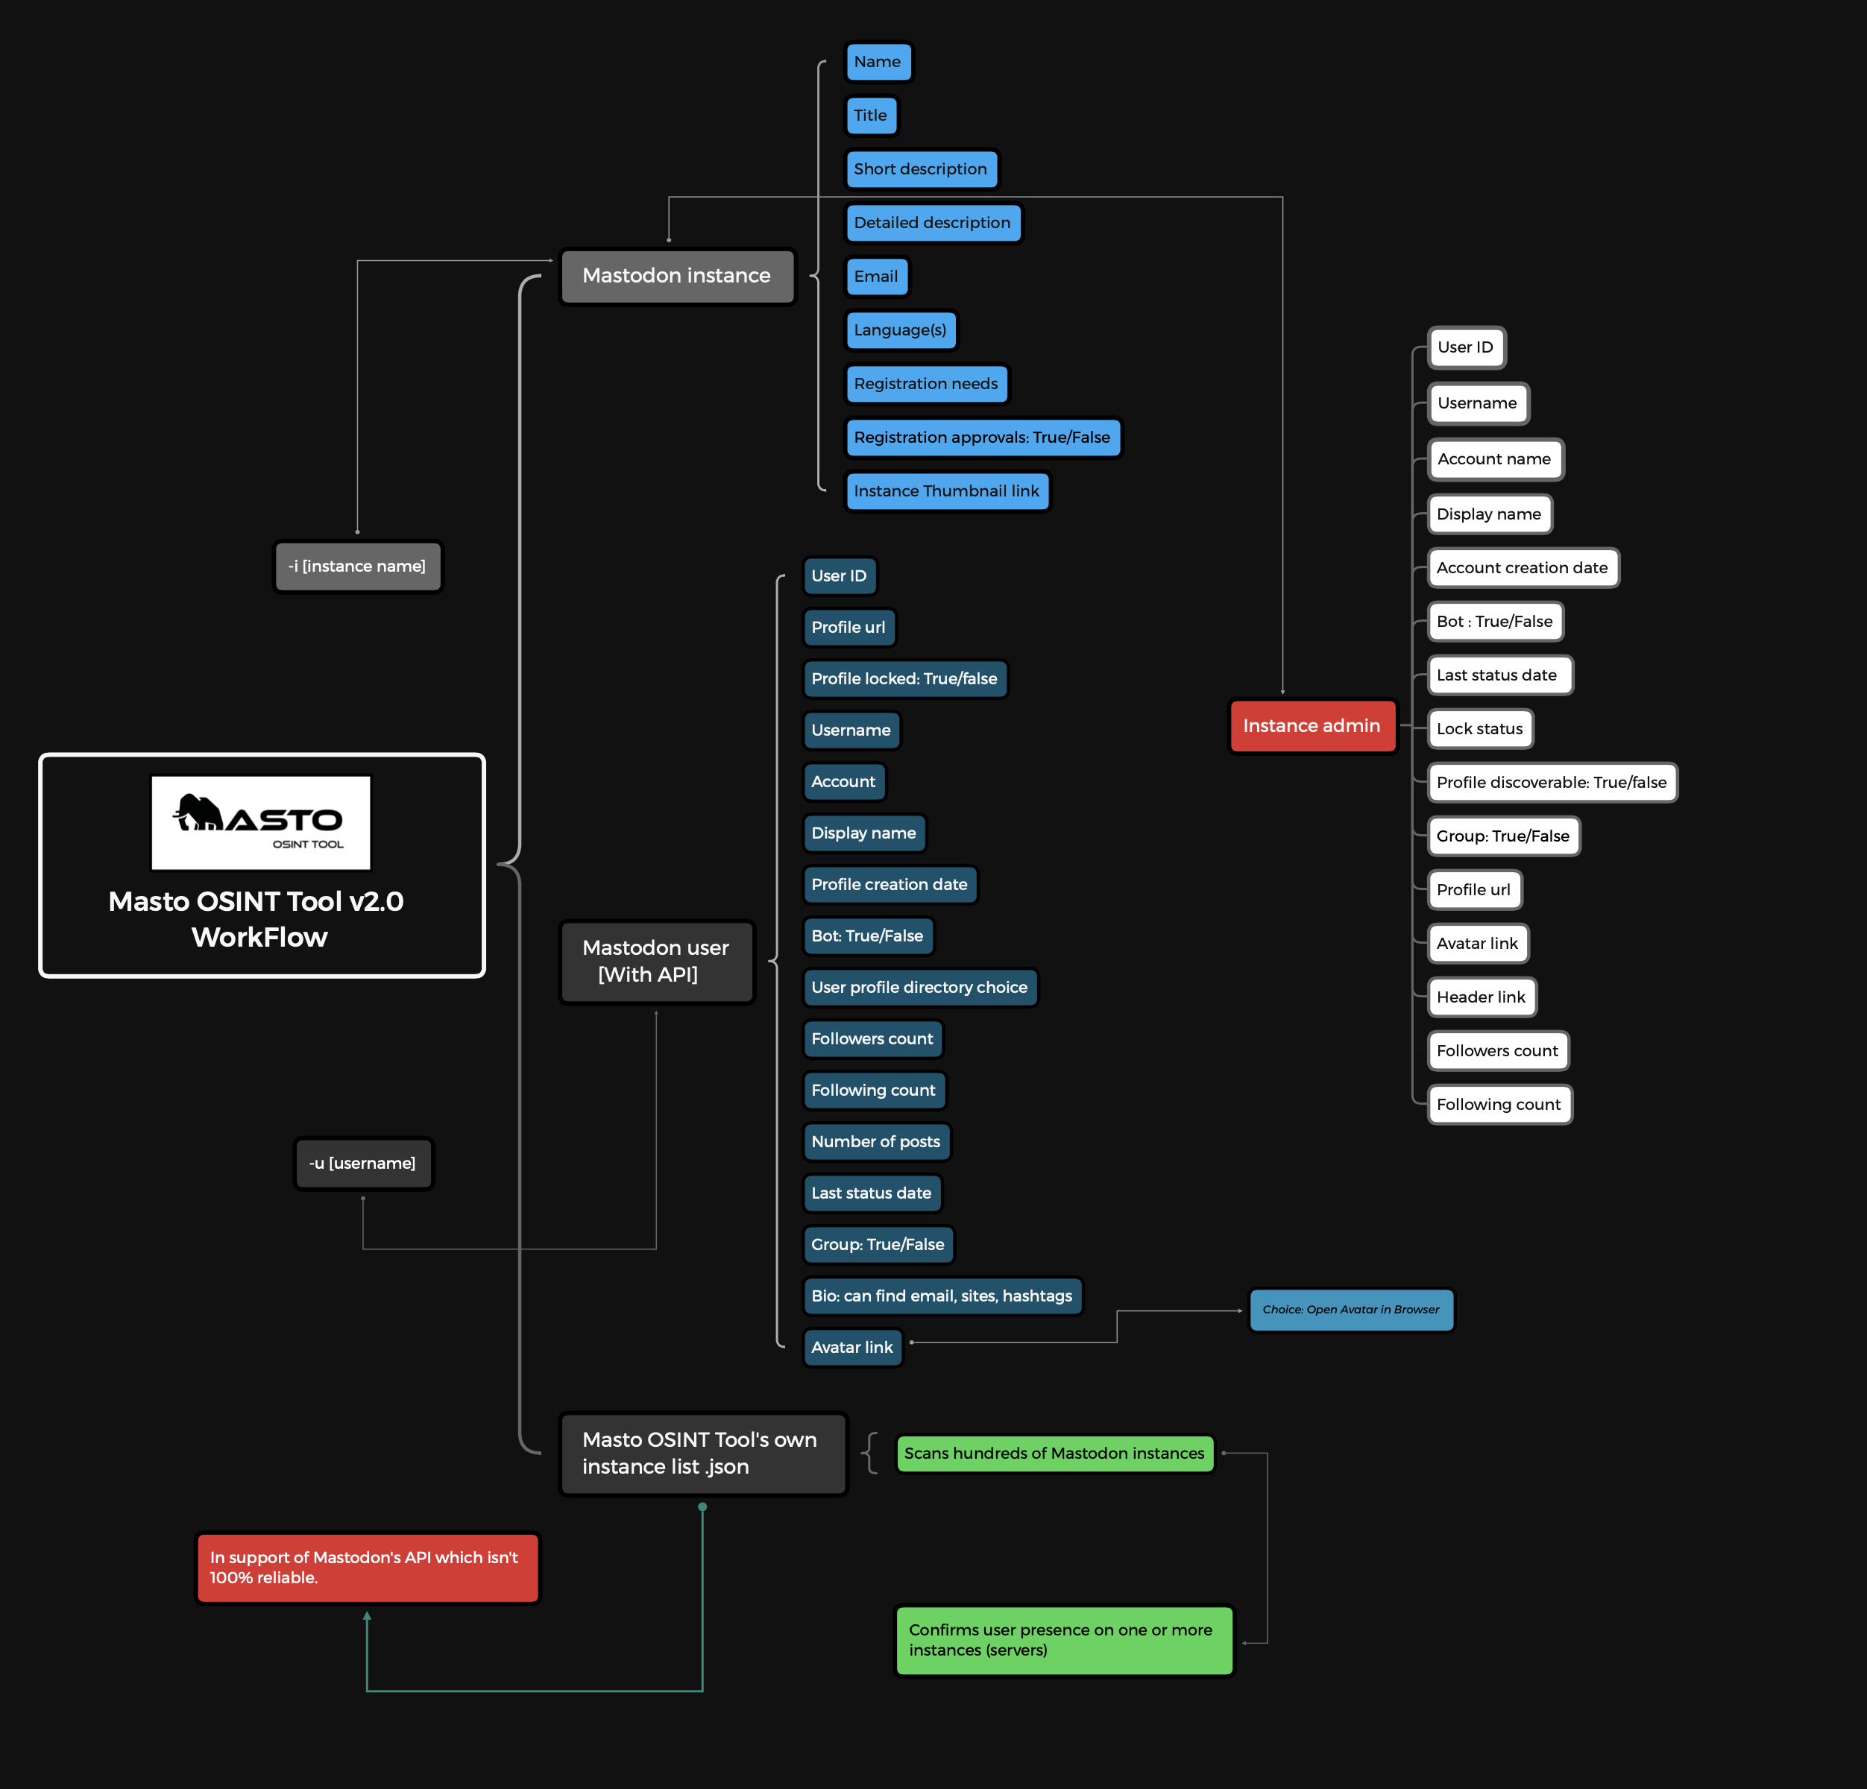](https://user-images.githubusercontent.com/104733166/201748872-60872350-3c70-4988-b3c0-31e3ca194a27.png)

**🛠️ Installation -**

1. **Using PyPI**

<https://pypi.org/project/masto/>

pip install masto==2.0.5

1. **Using GitHub**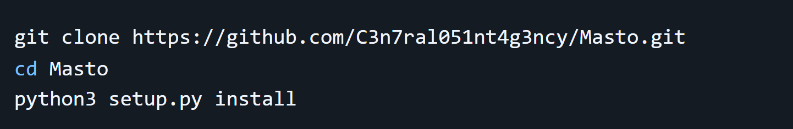

**👨‍💻 Usage -**

* Help: masto -h
* Search for user masto -user {username}
* Search for instance masto -instance {instance_name}

**⭐ Tool use cases -**

| **Use case 1** | **Searching for a user and bypassing the profile directory opt-out** |
| --- | --- |

* Tried searching via browser both terms Webbreacher and @Webbreacher **1 result** --> @Webbreacher@mastodon.social
* Searched Webbreacher on **Masto**: **3 results** --> ✅ 3 accounts found
* On the counter.social profile, @Webbreacher's settings are --> user opted to be on the profile directory = False, this is why the browser search didn't find the counter.social profile!

🪄 **Masto successful outcome**: **Masto found all 3 accounts**.

| **Use case 2** | **Searching without getting a 401 error** |
| --- | --- |

* Many people don't want an account on Mastodon, and if you don't have an account, you can search on Mastodon, but you will only get 5 results.
* Clicking on load more will give you a 401 error and request for the user to log in.

🪄 **Masto successful outcome**: **You can use Masto without logging in to Mastodon**, you won't get a 401 error.

| **Use case 3** | **Getting information on locked instances:** |
| --- | --- |

* Tried searching for the instance [0sint.social](https://0sint.social/about), there isn't much information via a browser search because it's locked.

🪄 **Masto successful outcome**: **Masto found more information on the instance and on the admin, including email address.**

| **Use case 4** | **Conducted a username search for Defcon:** |
| --- | --- |

* Conducted a search with Masto for the username defcon, the Mastodon API returned 2 user accounts.

🪄 **Masto successful outcome**: **Masto OSINT Tool picked up after the initial API search by doing a full scan and found 4 accounts.**

**🐘 Mastodon.social understanding -**

The **same username** can be found across different instances(servers):

* example: @osint@mastodon.social | @osint@mstdn.social | @osint@counter.social
* Finding the same username on different instances does not prove it's the same person behind each account.
* Each instance can only have **one unique username** in the server. Tip: verify your account with the <a rel="me" attribute which confirms you are behind the account, and will help avoid or detect impersonators.

**👤 Testing on known users and instances -**

* For a username test, try: python3 masto.py -u Gargron, the founder of [Mastodon.social](https://mastodon.social/), this pulls a wopping 11 accounts!!! (keep in mind that the same username doesn't prove the 11 accounts belong to @Gargron {Gargron is the Mastodon Dev}).
* For an instance test, try: python3 masto.py -i social.network.europa.eu

**⚪ Mastodon API reliability issues -**

* You may know of a valid user & have the link to the user's profile, you input the username on Masto but get no result.
* I asked the Mastodon Team about this api issue, they replied:

There is no global search, the server will reply with what it knows about. If it has not encountered the account, it will not return it in search results.

* 🟢 **Masto v2.0 fixes this**, the scan of Masto's own json instances list comes in support of Mastodon's API and picks up on things the API missed.
* **v2.0 is 100% reliable** if the server is listed in the Masto fediverse_instances.json file.
* This fix is thanks to [@Webbreacher](https://github.com/WebBreacher) who suggested this feature.

# Results Achieved by Some Users who used the tool (Sample Output) -

When analyzing a public account like @infosecnews@mastodon.social, the tool was able to retrieve:  
- Over 500 public posts.  
- Interaction data with over 300 distinct users.  
- Trends in hashtags such as #infosec and #cybersecurity.  
- Visual graphs representing the most frequent interaction nodes.  
  
Sample JSON output:  
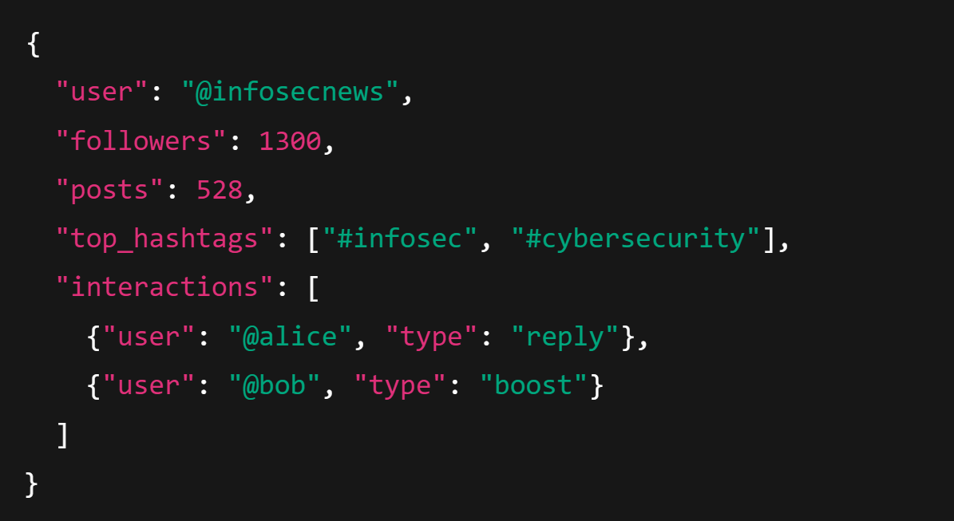

# Educational Use Cases, Limitations & Ethical Considerations

Educational Use Cases -  
- Cybersecurity training: Demonstrates how threat actors can be tracked through open networks.  
- Digital literacy: Teaches students about their digital footprint and how public data can be analyzed.  
- Research: Enables sociologists and digital ethnographers to study communication trends in federated networks.  
  
Limitations -  
- Limited to publicly accessible content; private posts and DMs cannot be accessed.  
- API rate limits and server restrictions may affect data retrieval.  
- Not all Mastodon instances share the same architecture, which may cause inconsistencies.

Ethical Considerations -  
- Always respect user privacy and only use data that is publicly available.  
- Avoid targeting or profiling individuals unfairly.  
- Disclose usage of such tools in research and educational projects.  
- Stay compliant with platform terms of service and applicable privacy laws.

Submitted by – Deeptansh Nagar

Team – 2 (Keshav Goyal & Deeptansh Nagar)  
Mail – [deeptansh.121033@stu.upes.ac.in](mailto:deeptansh.121033@stu.upes.ac.in)  
Contact - +91-9257417905